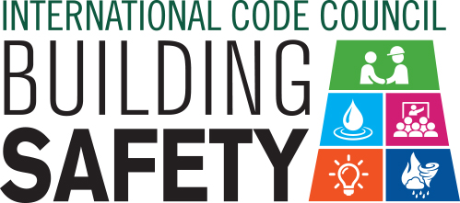
Proclamation
Building Safety Month — May, 2019

Whereas, our (City, Town, County, State) is committed to recognizing that our growth and strength depends on the safety and economic value of the homes, buildings and infrastructure that serve our citizens, both in everyday life and in times of natural disaster, and;

Whereas, our confidence in the structural integrity of these buildings that make up our community is achieved through the devotion of vigilant guardians––building safety and fire prevention officials, architects, engineers, builders, tradespeople, design professionals, laborers, plumbers and others in the construction industry––who work year-round to ensure the safe construction of buildings, and;

Whereas, these guardians are dedicated members of the International Code Council, a U.S. based organization, that brings together local, state and federal officials that are experts in the built environment to create and implement the highest-quality codes to protect us in the buildings where we live, learn, work, play, and;

Whereas, our nation benefits economically and technologically from using the International Codes® that are developed by a national, voluntary consensus codes and standards developing organization, our government is able to avoid the high cost and complexity of developing and maintaining these codes, which are the most widely adopted building safety and fire prevention codes in the world;

Whereas, these modern building codes include safeguards to protect the public from natural disasters such as hurricanes, snowstorms, tornadoes, wildland fires, floods and earthquake; which, according to a FEMA-commissioned study by the National Institute of Building Sciences, provide $11 in future mitigation benefits for every dollar invested, and;

Whereas, Building Safety Month is sponsored by the International Code Council to remind the public about the critical role of our communities’ largely unknown protectors of public safety––our local code officials––who assure us of safe, efficient and livable buildings that are essential to America’s prosperity, and;

Whereas, “No Code. No Confidence.” the theme for Building Safety Month 2019, encourages all Americans to raise awareness of the importance of safe and resilient construction; fire prevention; disaster mitigation, and new technologies in the construction industry. Building Safety Month 2019 encourages appropriate steps everyone can take to ensure the safety of our built environment, and recognizes that the implementation of safety codes by local and state agencies has saved lives and protected homes and businesses, and,

Whereas, each year, in observance of Building Safety Month, Americans are asked to consider the commitment to improve building safety and economic investment at home and in the community, and to acknowledge the essential service provided to all of us by local and state building departments, fire prevention bureaus and federal agencies in protecting lives and property.

NOW, THEREFORE, I, _______________________________, (Mayor, Supervisor, Commissioner, Governor) of the (City, Town, County, State) of ____________________________, do hereby proclaim the month of May 2019 as Building Safety Month. Accordingly, I encourage our citizens to join with their communities in participation in Building Safety Month activities.

_________________________________________________________________________
Signature

